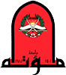

ERASMUS+ PROGRAMME
Promoting Youth Employment in Prompt Areas in Jordan/ Job-Jo
Project Number: 598428-EPP-1-2018-JO-EPPKA2-CBHE-JP

Minutes of the 6 Online Management Meeting

Online
Link:
Topic: JOB-JO Management Meeting
Time: Mar 19, 2021 02:00 PM Amman
Join Zoom Meeting
https://zoom.us/j/99954584161
Meeting ID: 999 5458 4161

March-19-2021

Participants list:
No. | Name of participant | Institute of Participant
1 | Prof. Omer Nawaf Khaled Maaitah - Coordinator | Mutah University
2 | Dr Mohammad Al majali - Technical Manger | Mutah University
3 | Dr Mohammed sarayreh | Mutah University
 | Saif Nawayseh | Mutah University
 | Prof. Ahmed Al- Salaymeh - Contact person UJ | UJ
 | Rasha Albik | UJ
4 | Prof Mohammad Almahasneh -Contact person | TTU
5 | Zubayda Riyad Almadadha -Contact Person GKM | GKM
6 | Prof. Suleiman Al khattab -Contact Person AHU | AHU
7 | Ghaith N. Alnawaiseh - Contact person MPWH | MPWH
8 | Prof. Fahmi Abu Al-Rub Contact person JUST | JUST
 | Ruba Hasen | JUST
9 | Evangelia Vanezi | UCY
10 | Alexandros Yeratziotis | UCY
11 | Professor Isabel Maria Vilaça Tavares Campos | ISAL.
12 | Dr. Lurdes de Jesus Leite Castanheira | ISAL.
13 | Prof. Dr.-Ing. Yaarob Al Ghanem | HTWK
14 | Oleg Krikotov | HTWK
15 | Riyadh Qashi | INT@E INT@E

19-3-2021

 | Chaired by Omer Maaitah
14:00 – 14:10 | - Prof. Fahmi Abu Alroub  - Progress in WP1 and what is next
14.10-14.30 | - Prof Yaaroub Ghanem  - Progress in WP2 and what is next
14.30-14.45 | - Dr Alexandros Yeratziotis  - Progress in WP3 and what is next
14.45-15.00 | - Isabel Vilaça /Lurdes Castanheira  - Progress in WP4 and what is next
15.00-15.15 | - Prof Ahmed Salymeh  - Progress in WP5 and what is next
15.15-15.30 | - Prof Omer Maaitah  - Stakeholders session result
15.30-15.45 | - Dr Mohamed Majali  - Coming activities
15.45-6.30 | - Discussion
6.30-6.35 | - Evaluation

Preamble
Mutah University, the grant holder for Job Jo project, arranged Zoom meeting on March-19-2021. This is the 6th meeting during the 3rd year of the project. The meeting was scheduled in one main session headed by the coordinator of the project Prof. Omer Maaitah. All contact persons attended the meeting. Attached is the agenda for the meeting. The output and results of this meeting are shown below:

1- Welcome in short words was presented by Prof. Omer Maaiteh /Project coordinator explaining the idea behind this meeting as impact of corona virus affected the activities of all projects.

2-Distribute the result of stakeholder meeting that held at Mutah university at 16-3-2021
2- Prof. Omer Maaitah, the project coordinator emphasized on finding a suitable way to continue implementing the main activities of the project during this crisis specially for the training and continuing establishing the center. The discussion between all partners were conducted based on this goal. Prof. Omer also informed all partners that the equipment for the center were received by Mutah University and distributed to all Jordanian Partners. He also confirmed that all the BSNBs were inaugurated in the Universities.

3- Prof. Fahmi Aburub, from JUST claimed that WP1 was completed as agreed by all partners. Discussion was carried out regarding the list of stake holders and networking. All agree on updating the list and send it to JUST which in turn will pass the final list to the coordinator.

4- Mr Oleg from HTWK presented the activities conducted on WP2. He showed all the tasks carried out on establishing the BSNBs. There was a discussion concerning that most of the activities were supervised and managed by MU and HTWK had no input on this WP. Debate was carried out to clarify this point and MU and HTWK agreed to conduct a bilateral meeting next Friday 26th Marc at 2 pm to finalize this point.

5- Prof. Ahmed Salymeh, the coordinator from UJ and the leader of WP5 presented all activities and dissemination conducted in all JO partners. He insisted on all partners to participate in dissemination and sustainability plans and send to UJ any activity intended to do.

6- Prof. Isabel Maria Vilaça Tavares Campos from ISLA introduced the status of WP4 and she revealed that the quality activities are ongoing process. She also presented the next training which will arranged by ISLA online to BSNBs in Jordan and asked all Jo partners to nominate trainees.

7- Alex from UCY, the leader of WP3, presented the capacity building plan and the required training courses for JO partners. He showed all completed training session and the next sessions. Many points were clarified by him. Extensive discussion was carried out on the training. All partners agreed on the physical training for the trainers. Also they agreed on conducting online training in BSBNs since the centers are inaugurated and if the quarantine continues. Dr. Alex talked about the updating of the website based on the feedback on the mid-report. MU and UCY agreed to conduct meeting to discuss these issue next Saturday (27th Marc at 2 pm)
Lateral meeting between UCY and MU will be held next week to discuss in detail all training issues

8. Dr. Mohammad Almajali presented the next activities to be conducted within the next 6 months. Those tasks are shown in the following table:

Task/Activity | Responsibility | Due date
Visiting JUST BSNBs by MU team | MU | Before 13th of April
Visit JU in Aqaba branch to conduct Training and face to face meeting | All Jordanian partners | before 13th of April
Submitting a progress report to include all activities since day one if possible | All partner | End of March  Including today presentation
Meeting between MU and HTWK | MU and HTWK | 26th march at 2 pm
Training for BSNBs by ISLA | All Jordanian Partners  And ISLA | April
Publishing the curricula for the training model | UCY | End of May
Quality reports | ISLA | Ongoing process

Task/Activity | Responsibility | Due date
Training activities | All Jordanian partners | On going process
Updating the website | MU | On going process
Training material | ISLA | 25th March
BSNB inf | All Jo partners | Template by JU
Meeting between MU and UCY | MU and UCY | 27th March at 2 pm
Updating the networking and stakeholders | JUST | 1st of April
Updating the networking and stakeholders list | JUST and other Jordanian partners | Tuesday 23rd of March
Letter for extension for the project | MU | Before August
Two online training UCY and HTWK | UCY and HTWK | May and June

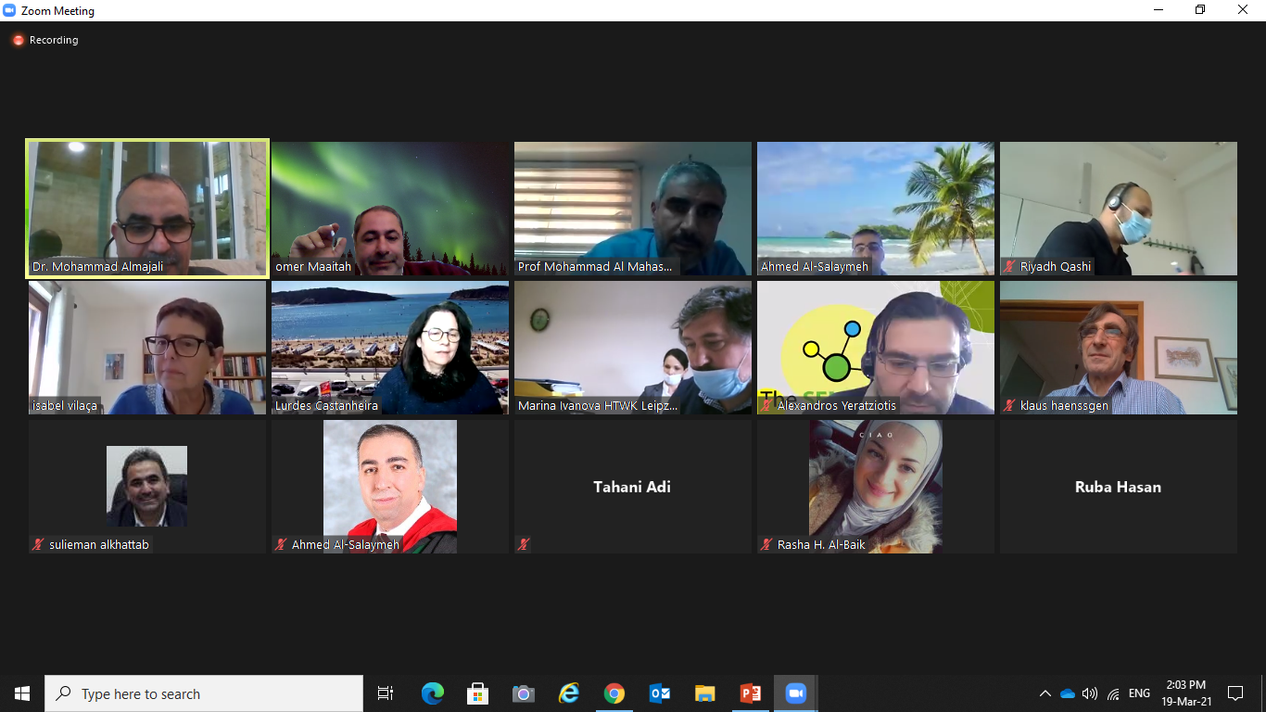

Disseminate the meeting via social media
